Spring MVC Basics
Model Entity
View Presentation Layer
Controller handles the request and response
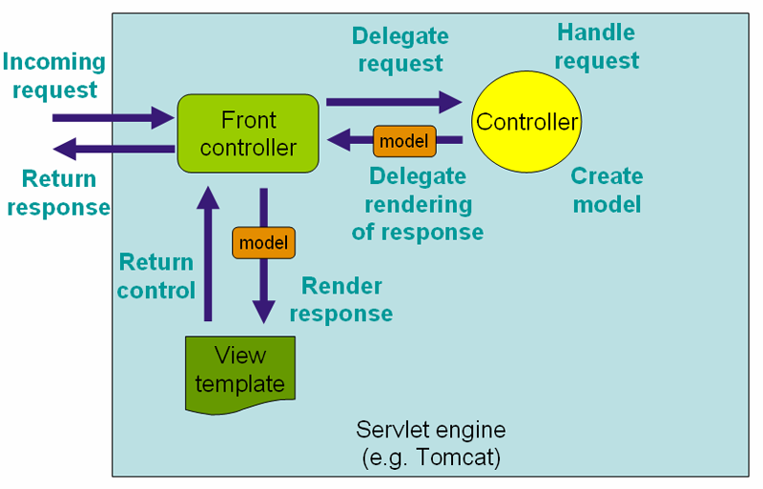
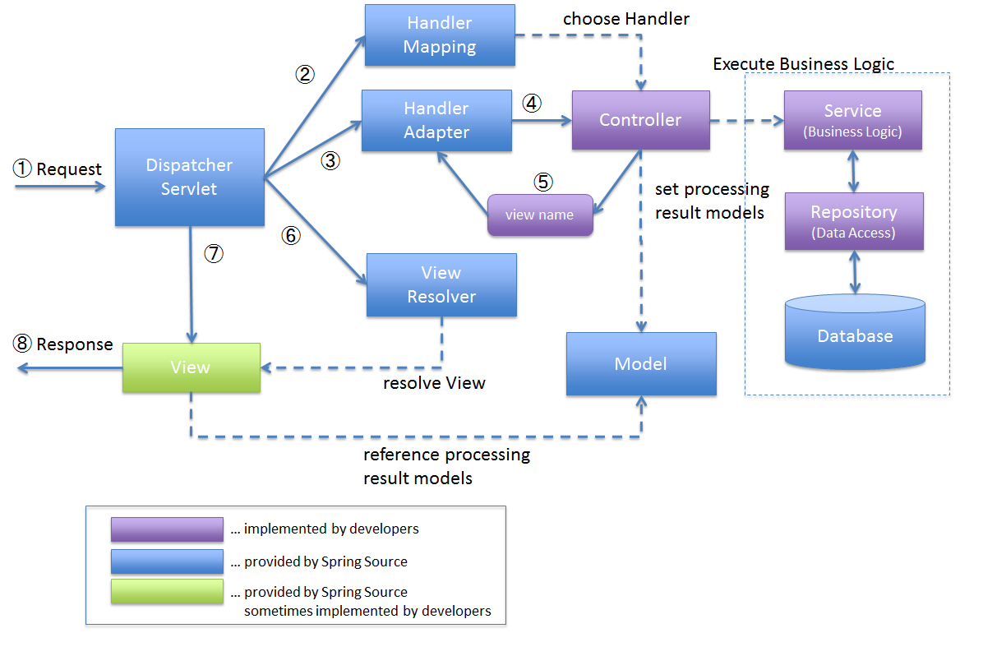

1️⃣ What is Spring MVC?
Spring MVC is a web framework provided by the Spring Framework to build web applications and REST APIs using the Model–View–Controller (MVC) design pattern.
👉 Spring MVC helps you:
- Receive HTTP requests (from browser / Postman / frontend)
- Process business logic
- Return responses (HTML / JSON / XML)

2️⃣ Why to Use Spring MVC?
Before Spring MVC, developers used:
- Servlets
- JSP with scriptlets
- Huge doPost() / doGet() methods
❌ Problems in old approach
- Tight coupling
- Hard to maintain
- No clear separation of logic
- Difficult testing
✅ Spring MVC solves this by:
- Separating concerns (Controller, Service, View)
- Reducing boilerplate code
- Making applications scalable and testable
- Easy REST API creation

3️⃣ Purpose of Spring MVC
Spring MVC is mainly used to:
- Build web applications
- Build RESTful APIs
- Handle HTTP requests cleanly
- Support modern frontend frameworks (React, Angular, Mobile Apps)

4️⃣ MVC Architecture
MVC stands for:
Layer | Responsibility
Model | Holds data (Entity, DTO, POJO)
View | UI (JSP, Thymeleaf, HTML, JSON)
Controller | Handles requests & responses
Real-world analogy
🧑 Customer → 📋 Waiter → 🍳 Kitchen → 📋 Waiter → 🧑 Customer

5️⃣ Spring MVC Architecture (How It Works Internally)
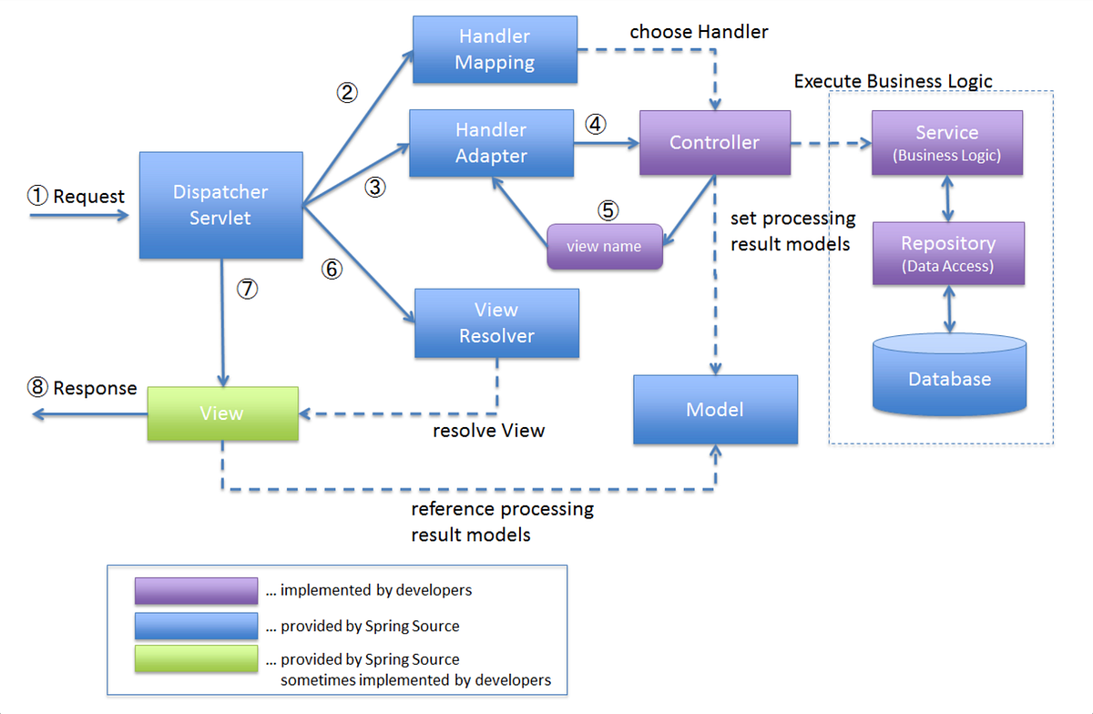

Step-by-step Flow
- Client sends HTTP request
- DispatcherServlet receives it (Front Controller)
- Finds correct Controller
- Controller executes logic
- Returns response
- DispatcherServlet sends response back to client

6️⃣ Spring Boot and Spring MVC Integration
Why Spring Boot?
Spring MVC alone requires:
- XML config
- DispatcherServlet setup
- ViewResolver config
Spring Boot simplifies everything:
- Auto-configuration
- Embedded Tomcat
- No XML needed
- Faster development
👉 Spring Boot + Spring MVC = Production-ready Web App

7️⃣ Controllers
What is a Controller?
A Controller is a Java class that:
- Handles HTTP requests
- Calls service layer
- Returns response
@Controller
public class HomeController {
@GetMapping("/home")
public String home() {
return "home";
}
}

8️⃣ @Controller vs @RestController
Annotation | Use
@Controller | Returns View (HTML/JSP)
@RestController | Returns Data (JSON/XML)
@RestController = @Controller + @ResponseBody
@RestController
public class ApiController {
@GetMapping("/hello")
public String hello() {
return "Hello API";
}
}

9️⃣ @RequestMapping
What is it?
Maps HTTP requests to controller methods.
@RequestMapping("/users")
public class UserController { }
- Can be used at class or method level
- Supports all HTTP methods

🔟 @GetMapping, @PostMapping
Annotation | HTTP Method
@GetMapping | GET
@PostMapping | POST
@PutMapping | PUT
@DeleteMapping | DELETE
@GetMapping("/users")
public List<User> getUsers() { }

1️⃣1️⃣ @PutMapping, @DeleteMapping
Used for REST APIs:
@PutMapping("/users/{id}")
public User updateUser() { }

@DeleteMapping("/users/{id}")
public void deleteUser() { }

1️⃣2️⃣ @PathVariable vs @RequestParam
@PathVariable
Used for URL values
@GetMapping("/users/{id}")
public User get(@PathVariable int id) { }
@RequestParam
Used for query parameters
@GetMapping("/users")
public User get(@RequestParam int id) { }
URL examples:
- /users/10 → PathVariable
- /users?id=10 → RequestParam

1️⃣3️⃣ @RequestBody & @ResponseBody
@RequestBody
Converts JSON → Java Object
@PostMapping("/users")
public User save(@RequestBody User user) { }
@ResponseBody
Converts Java Object → JSON
@GetMapping("/users")
@ResponseBody
public User get() { }
⚡ Automatically handled by Jackson library

🔁 Complete Request Lifecycle (Beginner Flow)

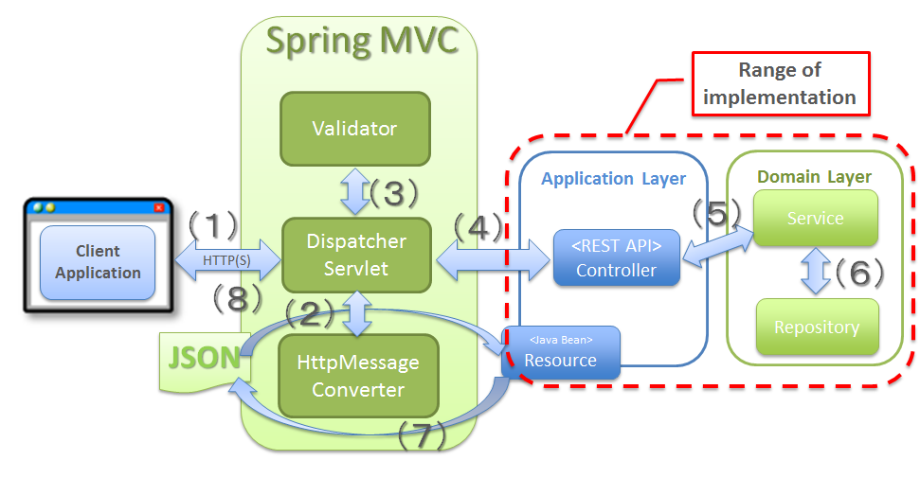
- Browser / Postman sends request
- DispatcherServlet intercepts
- Controller method executes
- Service layer logic
- Response converted to JSON/HTML
- Sent back to client

🧠 Summary (Interview-Friendly)
- Spring MVC is a web framework
- Uses MVC architecture
- DispatcherServlet is the heart
- Controllers handle requests
- Annotations simplify mapping
- Spring Boot makes setup effortless

